

**Game Design Document for:**

**The Rising Darkness**

May the darkness live in you

**All work Copyright ©2014 Bergen Community College**

**Written by Alex Reitmeyer**

**Version # 1.00**

**Monday, July 24, 2017Table of Contents**

Design History 4

Version 1.00 4

Version 1.10 4

Version 2.00 4

Version 2.10 4

Game Overview 5

High Concept 5

Philosophy 5

Philosophical point #1 5

Philosophical point #2 5

Philosophical point #3 5

Common Questions 6

Feature Set 8

Feature Highlights 8

Feature Details 10

Job Classes 10

Gameplay 22

Multiplayer Features 22

Editor 22

Single-Player Game 23

Single Player Game Detail #1 23

Single Player Game Detail #2 23

Story 23

Detailed Walkthrough 23

Beat Chart 23

Hours of Gameplay 23

Victory Conditions 23

Multiplayer Game 24

Max Players 24

Servers 24

Customization 24

Internet 24

Gaming Sites 24

Persistence 24

Saving and Loading 24

Camera 25

Overview 25

Camera Detail #1 25

Camera Detail #2 25

The Game World 26

World Feature #1 26

World Feature #2 26

The World Layout 26

Overview 26

World Layout Detail #1 26

World Layout Detail #2 26

The Physical World 26

Overview 26

Key Locations 26

Travel 26

Scale 26

Objects 27

Weather 27

Day and Night 27

Time 27

World Editing 27

World Editing Detail #1 27

World Editing Detail #2 27

Game Characters 28

Creating a Character 28

NPC Characters 28

Enemies and Monsters 28

Weapons 29

Weapons Details #1 29

Weapons Details #2 29

Vehicles 30

Vehicle Details #1 30

Vehicle Details #2 30

User Interface - Controls 31

User Interface Detail #1 31

User Interface Detail #2 31

Game Interface - Menus 32

Screen Flow Diagrams 32

User Interface Detail #1 32

User Interface Detail #2 32

User Interface Detail #3 32

HUD/On Screen Displays 32

Wireframes 32

Musical Scores and Sound Effects 33

Sound Design 33

Extra Miscellaneous Stuff 34

APPENDICES 35

“XYZ” Appendix 35

“Competitive Analysis” Appendix 35

“Game Interface – Menus” Appendix 35

“Objects” Appendix 35

“Story” Appendix 35

“Technical Specs Appendix” 36

Rendering System 36

Game Engine 36

Collision Detection 36

Lighting Models 36

# Design History

This is a brief explanation of the history of this document. Each version of this document is based on when a document is released for feedback/review, or major changes/additions have been made.

### Version 1.00

Initial pass at design.

### Version 1.10

Version 1.10 includes some tuning and tweaking that I did after making my initial pass at the design. Here is what I changed.

1. I rewrote the section about what systems the game runs on.
2. I incorporated feedback from the team into all parts of the design however no major changes were made.
3. Just keep listing your changes like this.

### Version 2.00

Version 2.00 is the first version of the design where a major revision has been made now that much more is known about the game. After many hours of design, many decisions have been made. Most of these large design decisions are now reflected in this document.

Included in the changes are:

1. Pairing down of the design scope. (Scope, not design)
2. More detailed descriptions in many areas, specifically A, B and C.
3. This is included here to see if you are paying attention
4. Story details.
5. World layout and design.

### Version 2.10

Version 2.10 has several small changes over that of version 2.00.

The key changes are in many of the appendixes.

Included in the changes are:

1. Minor revisions throughout entire document.
2. Added “User Interface Appendix”.
3. Added “Game Object Properties Appendix”.
4. Added concept sketch for world.

# Game Overview

## High Concept

“The Rising Darkness” is made in honor of old school 3d platformers like Banjo-Kazooie, Donkey Kong 64, or Sypro. It takes place in the world of Subspace, a dimension in between space and time. You play as Morte Renata in order to seize control of Subspace and overthrow Lucem, the current queen of Subspace. The player must collect 10 dark orbs in the 20 worlds in order to advance to more parts of Subspace. Collect dark shards to gain more dark powers and defeat bosses in order to gain more elemental abilities.

## Philosophy

The philosophy behind "The Rising Darkness" is to revive 3D platforming games in a game industry where platformers are a rare style of video game. Over the years, there has been a large number of First Person Shooters that have saturated the games industry and not enough games that offer platforming elements like Super Mario Galaxy. This game seeks to regain people’s interest in 3D platformers and create a new generation of inspired and innovative games not seen since the N64 era of video games.

## Common Questions

**What is the game?**

The game is a 3d platformer is the style of N64 and Playstaion collectathons like Banjo-Kazooie and Spyro.

**Why create this game?**

This game is being created in response to the lack of 3d platformers in today’s age of video games.

**Where does the game take place?**

The game takes place in the dimension of Subspace.

**What do I control?**

You play as Morte Renata, an umbramancer who gets bored one day, so he decides take over the world of Subspace.

**How many characters do I control?**

You only control Morte Renata.

**What are the Goals/Objectives of the game?**

The goal of the game is to usurp the dimension of Subspace from Lucem, the Light Queen. This is done by collecting the dark orbs scattered throughout Subspace and its many lands.

**What is the main focus?**

The main focus of the game is Morte Renata traveling through Subspace collecting dark orbs and dark shards to gain more strength and powers to become the ruler of Subspace.

**What’s different?**

The main difference of the game is that you control the antagonist, Morte Renata instead of the protagonist, Lucem. His main goal is to usurp the throne and bring about darkness into.

# Feature Set

## Feature Highlights

**Control the Powers of Darkness**

Play as Morte Renata who has the power of darkness and can use to defeat his enemies.

**Customize your abilities**

Customize your abilities when you learn more dark powers.

**Co-op**

Play together with your friend.

## Feature Details

This should be broken into a separate detailed section for each of your game features listed above, with enough detail for a development team to implement the feature. The features should be listed in order of priority, and can be broken up into different areas as are listed below, or simply listed in order as in overview. This is the core of the design doc!

### 

### Gameplay

**Power of Darkness**

**Umbra Trident**

Morte Renata has the ability to use dark magic and control his shadow with the use of his main weapon, the “Umbra Trident.”

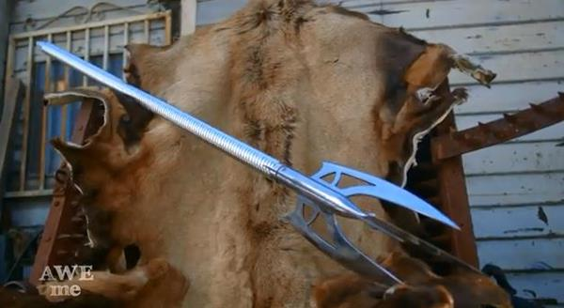

**Dākubaunsu (Dark Bounce)**: This allows Morte to double jump.

**Dopperugengā (Doppleganger)**: This allows Morte to create a clone to hold down switches or help fight.

**Shadoubaindo (Shadow Bind):** This allows Morte to use his shadow to hold enemies into place.

**Mabataki (Blink):** This allows Morte to teleport are short distance. This can only be used on the ground.

**Shadō kōka (Shadow Descent):** This allows Morte slow down his descent.

**Dai uzumaki (Maelstrom):** This allows Morte to create a vortex of darkness.

**Shadouai (Shadow Eye):** This allows Morte to see invisible objects and enemies.

**Kuraimakkusu (Climax):** This is the final and most powerful technique in Morte’s arsenal. He used all the power absorbed from the bosses and fires out a laser. It can only be used against the final boss and as the finishing move.

**Kurai tenteki (Dark Infusion):** This allows Morte to imbue himself or his weapon with darkness, increasing his power.

**Shūchū hōka (Barrage):** Morte thrusts his trident in a rapid fire style against his opponent.

**Supinkikku (Spin Kick):** Morte sticks his trident into the ground and performs a spin kick.

**Katsu tame ni supin (Spin to Win):** Morte spins in a circle with his trident extended outwards.

**Customize your abilities**

Most of these moves can be customized in the pause screen to suit the players fighting style. All you have to do is go to a window in the pause menu to swap the abilities you want to use.

**Collectable Items**

In the game, you will need to find Dark Orbs. These function in the same as stars in “Mario” games and Jiggies in “Banjo-Kazooie.” You collect them in order to unlock new levels in Subspace until you get enough to go to Lucem’s Castle. There are 10 dark orbs in each world. You collect these orbs by finding them out in the open, solving puzzles, going through platforming segments, fighting a boss, or collecting all the Dark Shards in a level. Dark Shards are what allow you to unlock more moves that you can use. There are 100 Dark Shards in every world and collecting all of them awards you with a Dark Orb. There are also Shadow Fragments. Collecting one gives Morte an extra life.

**Bosses**

Throughout the game, you will encounter bosses, such as “Jewel Fletcher Cristallum,” “Necromancer Pursel” and “Wind Slasher Arashi.” Defeating them will award you with a dark orb and even a new weapon. These weapons can do what the Umbra Trident can do, but with different elements and an exclusive move. With the exclusive moves that the weapons provide, you will be able to collect Dark Orbs you could not collect earlier or help you in combat.

**Combat**

The combat is also another main feature of the game. It functions in the same way that the “Ratchet and Clank” games handle fighting. The more enemies you kill, the more health you will get. This also applies to the weapons. The more they are used, the stronger they become.

### Multiplayer Features

**Co-op**

“The Rising Darkness” supports co-op. When you have a second person and controller, you can use Dopperugengā (Doppleganger), for the second person to control. The clone has the same moves as Morte, except that it cannot use the weapons gained from bosses, only a shadow version of the “Umbra Trident.” This functions the same way “Sonic the Hedgehog 2” does, in which both of the characters are on the same screen.

### 

# Single-Player Game

**Overview**

Describe the single-player game experience in a few sentences.

Here is a breakdown of the key components of the single player game.

### Single Player Game Detail #1

The platforming is designed to be similar to games like Banjo-Kazooie and Spyro the Dragon. The puzzles are inspired from the dungeons in Zelda games. The combat is to be similar to take of “Ratchet and Clank.”

### Story

The story is that Morte Renata, a wandering umbramancer, wants to become the strongest in all of Subspace. He believes that going against Lucem, the Light Queen, would be a perfect way to become stronger. So he massacres a village in order to get her attention. Lucem then sends her strongest warriors, the Elementals to kill him in fear that Morte would cause more trouble. Then the adventure begins. After traveling through all 20 worlds, defeating all the Elementals, and gathering 150 Dark Orbs, Morte makes his way to Lucem’s castle. After a destructive duel that ends with Lucem being blasted through a mountain, Morte absorbs her power and becomes the new ruler of Subspace.

## Detailed Walkthrough

### Beat Chart

Go to Fiery Forest: Opened from the start.

Go to Liquid Temple: Collect 6 dark orbs and fight “Pyromaniac” Ignis to unlock.

Go to Lightning Spire: Collect 13 dark orbs and fight “Whirlpool Maker” Agua to unlock.

Go to Poison Swamp: Collect 19 dark orbs and fight “Bolt Striker” Kaminari to unlock.

Go to Undead Crypt: Collect 25 dark orbs and fight “Biohazard” Morbus to unlock.

Go to Frosty Summit: Collect 33 dark orbs and fight “Necromancer” Pursel to unlock.

Go to Crag Mountain: Collect 41dark orbs and fight “Icicle Assassin” Frigus to unlock.

Go to Tornado Alley: Collect 49 dark orbs and fight “Living Statue” Ishi to unlock.

Go to Steel Factory: Collect 60 dark orbs and fight “Wind Slasher” Arashi to unlock.

Go to Clockwork Carnage: Collect 71 dark orbs and fight “Master Forger” Ferrum to unlock.

Go to Beast Labs: Collect 78 dark orbs and fight “Chrono Knight” Jikan to unlock.

Go to Life Grove: Collect 85 dark orbs and fight the Hybrid Master to unlock.

Go to Nuclear Reactor: Collect 93 dark orbs and fight to “Cleric” Sanaret unlock.

Go to Crystal Grotto: Collect 100 dark orbs and fight “Radioactive” Hoshasen to unlock.

Go to Shining Cove: Collect 106 dark orbs and fight “Jewel Fletcher” Cristallum to unlock.

Go to Napalm Harbor: Collect 114 dark orbs and fight “Light Protégé” Lux to unlock.

Go to Dark Cavern: Collect 122 dark orbs and fight the Napalm Wraith to unlock.

Go to Phantom Manor: Collect 129 dark orbs and fight “Dark Void” Teneb to unlock.

Go to Lava Ocean: Collect 133 to and fight the Poltergeist to unlock.

Go to Lucem’s Castle: Collect 141 dark orbs and fight the Magma Demon to unlock.

Fight Lucem: Collect 150 dark orbs to fight.

### 

### Hours of Gameplay

If the player is only going to the minimum of the dark orbs required to beat the game, the game will only take 10 hours to beat. If the player is planning to beat everything, the game would take about 15 hours to beat it.

### Victory Conditions

In order to beat the game, the player must defeat all the bosses that reside in each of the levels. The player must also collect at least 150 dark orbs in order to reach the final level and the final boss.

# Camera

## Overview

Describe the way the camera will work and then go into details if the camera is very complicated in sub sections. Show example images of what the gameplay view will look like!!!

## Camera Detail #1

The camera functions the same way as it does in Super Mario 64.

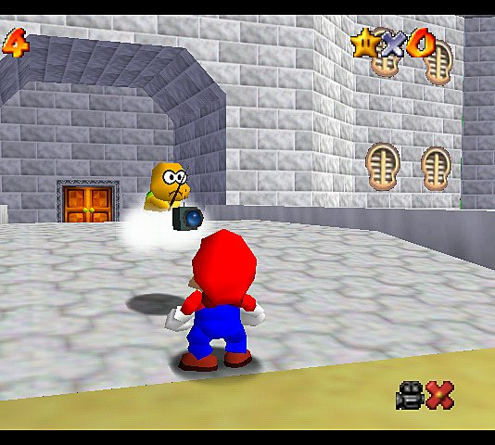

## Camera Detail #2

The camera will sometimes move like this in this special circumstance.

# The Game World

**Overview**

Subspace is a world where only the strongest can live and rule. Everyone born is trained to become the strongest. Subspace is mainly composed of mountains, forests, oceans, caves, temples, and factories but other elements can become part of them. For example, there is one level where a forest is always on fire but nothing burns.

### World Feature #1

This section is not supposed to be called world feature #1 but is supposed to be titled with some major thing about the world. This is where you break down what is so great about the game world into component pieces and describe each one.

### World Feature #2

Same thing here. Don’t sell too hard. These features should be awesome and be selling the game on its own.

## The World Layout

### Overview

**Fiery Forest:**

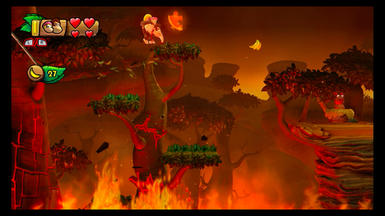

**Liquid Temple:**

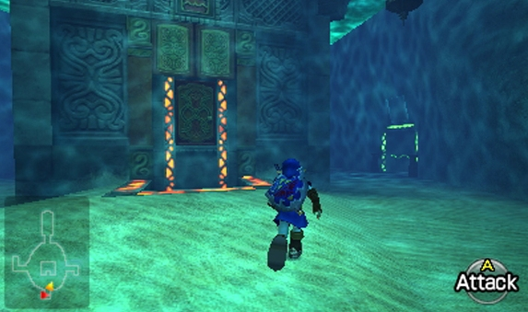

**Beast Labs:**

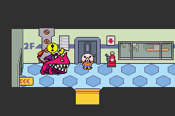

### World Layout Detail #2

## The Physical World

### Overview

Subspace is mainly composed of mountains, forests, oceans, caves, temples, and factories but other elements can become part of them. For example, there is one level where a forest is always on fire but nothing burns and an ocean of lava.

### Key Locations

There are 20 levels in the game. These levels are Fiery Forest, Liquid Temple, Lightning Spire, Poison Swamp, Undead Crypt, Frosty Summit, Crag Mountain, Tornado Alley, Steel Factory, Clockwork Carnage, Beast Labs, Life Grove, Nuclear Reactor, Crystal Grotto, Dark Cavern, Napalm Harbor, Shining Cove, Phantom Manor, Lava Ocean, and Lucem’s Castle.

### Travel

The player travels through the world on foot and has no vehicles. There are however, teleporters that can be used to travel to areas previously visited.

### Scale

The world of Subspace’s scale is on par with The Legend of Zelda: Twilight Princess.

### Objects

Dark Orbs: These are used to access more levels in the game. For example, 6 dark orbs are needed to access Liquid Temple.

Dark Shards: Dark Shards are used in order to gain new moves. For example, 50 dark shards are needed to unlock Dākubaunsu (Dark Bounce). Collecting all 100 in a level awards you with another dark orb.

### Weather

Weather only appears in certain levels. For example, Frosty Summit will always be snowing and Tornado Alley will always be raining.

### Day and Night

There is no day and night cycle.

### Time

The time in the game functions the same way it does in the real world.

# Game Characters

**Overview**

Overview of who or what your characters are. Sketches or Diagrams are really helpful.

### Creating a Character

Morte Renata: He is the main character of the game. Morte is a wandering umbramancer seeking to increase his strength. He figures the best way to do that is to fight the ruler of Subspace, the Light Queen, Lucem. Knowing a direct assault wouldn’t end well, he destroys a village and everyone in it to get her attention. He then begins his adventure with the power of darkness in tow.

### NPC Characters

Lucem: The ruler of Subspace.

“Jewel Fletcher” Cristallum: Boss of Crystal Grotto.

“Necromancer” Pursel: Boss of Undead Crypt.

“Wind Slasher” Arashi: Boss of Tornado Alley.

### 

### Enemies and Monsters

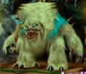

Yeti: Found in Frosty Summit.

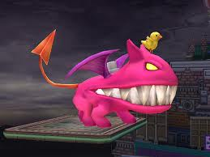

Hybrid Master: Boss of Beast Labs.

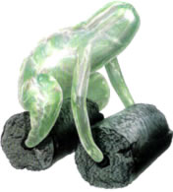

Hydro Sapien: Found in Liquid Temple.

# Weapons

**“Umbra Trident”**



All of the other weapons can do what the Umbra Trident can do, but with different elements and an exclusive move.

**“Pyro Glaive”**

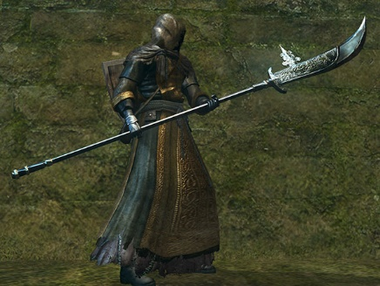

Hītoappu suru (Heat Up): Morte heats up the glaive to make his attacks stronger or melt ice.

**“Arctic Rapier”**

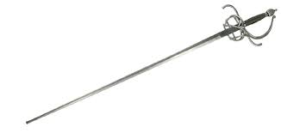

Tōketsu sasu (Freeze Stab): Morte thrusts the sword and freezes what it hits.

**“Katanitachi”**

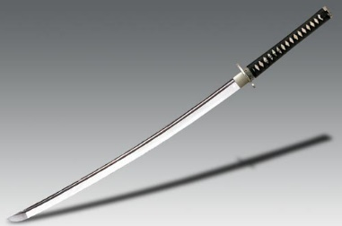

Kaze no katto (Wind Cut): Morte slashes the katana and it releases a slicing wind.

**“Quake Hammer”**

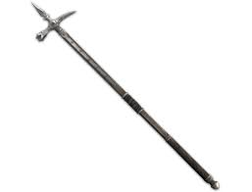

Kiretsu (Fissure): Morte slams the hammer to the ground that creates a fissure and raises a stalagmite. Morte can jump on the stalagmite.

**“Wire Gauntlet”**

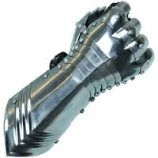

Waiyā dangan (Wire Bullet): Morte fires a metal wire like a bullet. Morte can use this as a grappling hook and a way to swing.

**“Zap Javelin”**

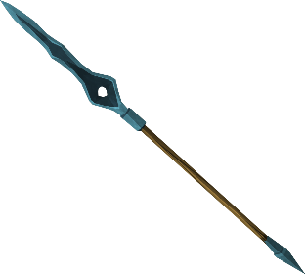

Boruto mahō (Bolt Enchantment): Morte electrifies the javelin to make his attacks stronger. It can also be used to power up machines.

**“Jewel Bow”**

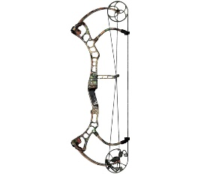

Hōseki no shigi (Gem Snipe): Morte fires an arrow made out of a crystal to pierce his foes from afar. It can be used to hit out of reach switches.

**“Hydro Harpoon”**

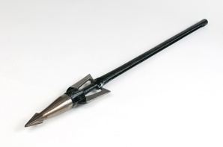

Mizu tosu (Water Toss): Morte throws his harpoon at an enemy and it fills it with water until they explode. It can be used to cool down hot surfaces.

**“Staff of the Dead”**

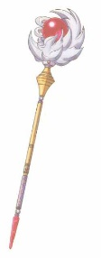

Futatabi jōshō (Rise Again): Morte uses the staff in order to raise the dead and help him fight.

**“Light Claw”**

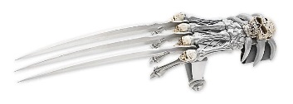

Hakkō surasshu (Luminous Slash): Morte swings his claw to create a shining slash. It can be used to brighten dark areas.

**“Injector”**

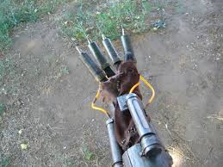

Hiso (Arsenic): Morte uses the needles on the gauntlet to inject his enemy with poison. This can damage an enemy overtime.

**“Chrono Mace”**

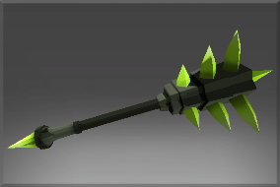

Jikan furakkusu (Time Flux): Morte creates a dome where time is slowed down. It can also be used to speed up Morte.

**“Atomic Chakram”**

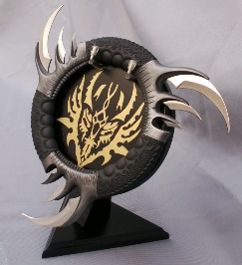

Totsuzenhen'I (Mutation): Morte throw his chakram at an enemy that mutates them and causes them to help you fight.

**“Life Catcher”**

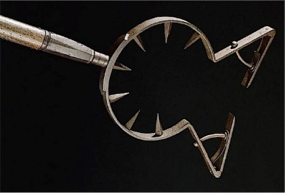

Manadorein (Mana Drain): Morte catches his enemy to drain them of their life force, which in turn, heals Morte.

# Teleporters

**Overview**

There are teleporters spread throughout the land of Subspace. They are all located near the entrance to a level. The can be used when you find it for the first time. This makes traveling in Subspace faster when you want to go back to previous levels.

# User Interface - Controls

**Overview**

Provide some sort of an overview to your interface and same as all the previous sections, break down the components of the UI below. ALWAYS include a diagram of the control interface, whether it is a controller or a Keyboard/Mouse combination. If you are creating an RTS style game, the on screen selectable menus are your CONTROL INTERFACE… show them to us.

### User Interface Detail #1

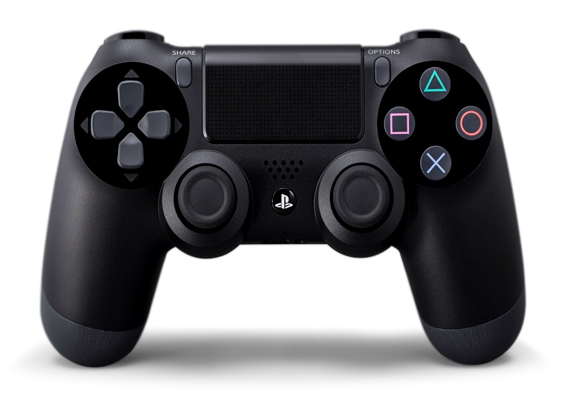

Left analog stick - Movement

* Press to sprint

Right analog stick – camera control

Trinagle – Attack

X – Jump : twice to perform a double jump

O – Attack

Square – Attack

Option – Pause

R1 – cycle through weapons #1 and #2

R2 – use Shadō kōka (Shadow Descent)

L1– cycle through weapons #2 and #1

L2 – use Mabataki (Blink)

# Game Interface - Menus

**User Interface**

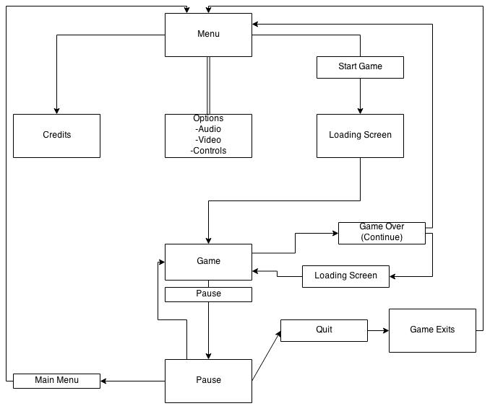

## HUD/On Screen Displays

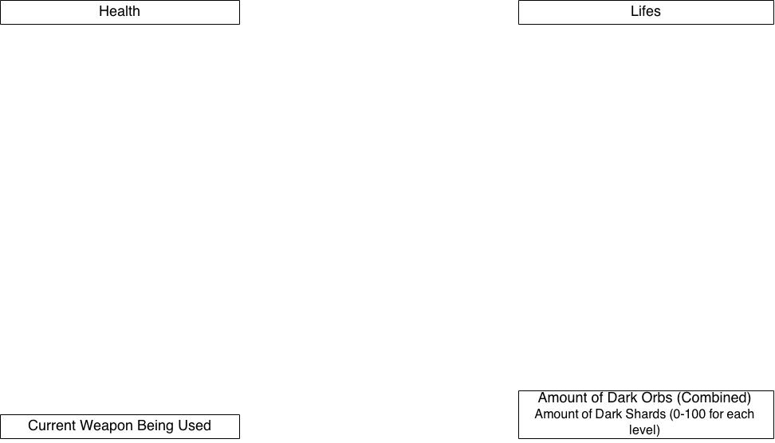

# Musical Scores and Sound Effects

**Overview**

This should probably be broken down into two sections but I think you get the point. What is the style of music that you want your game to use.

## Sound Design

The music of the game is mainly to be orchestrated like Super Mario Galaxy. The main difference is that the music is used to get you into the mood of exploring and fighting.

# Extra Miscellaneous Stuff

**Overview**

Drop anything you are working on and don’t have a good home for here.

Junk I am working on…

Crazy idea #1

Crazy idea #2

# APPENDICES

## “XYZ” Appendix

Provide a brief description of what this appendix is for and then get down to business and provide data to the reader. Appendices are where you provide depth of details, spreadsheets of all your character attributes, lists of all your objects, wireframes for each of your screens. Any research information that you think your development team might need to create the game ie. Rules, Stats, Specs, History

Here are a few examples of some of the appendices that should appear in your design…

## “Competitive Analysis” Appendix

## “Game Interface – Menus” Appendix

## “Objects” Appendix

## “Story” Appendix

## “Technical Specs Appendix”

This section would normally be part of a TDD document, and should only be included if the Rendering, Game Engine, or Lighting system is a key feature of your game. Let’s see if you read this sentence.

### Rendering System

.

**Overview**

Give an overview of how your game will be rendered and then go into detail in the following paragraphs.

**2D/3D Rendering**

Describe what sort of 2D/3D rendering engine will be used.

### Game Engine

### 

**Overview**

Describe the game engine in general.

**Game Engine Detail #1**

The game engine will keep track of everything in the world like such and such.

**Water**

There will be water in the world that looks awesome and our game engine will handle it beautifully.

### Collision Detection

Our game engine handles collision detection really well. It uses the such and such technique and will be quite excellent. Can you see I am having a hard time making up stupid placeholder text here?

### Lighting Models

**Overview**

Describe the lighting model you are going to use and then go into the different aspects of it below.

**Lighting Model Detail #1**

We are using the xyz technique to light our world.

**Lighting Model Detail #2**

We won’t be lighting the eggplants in the game because they are purple.